


Latham Primary School
Preschool Handbook
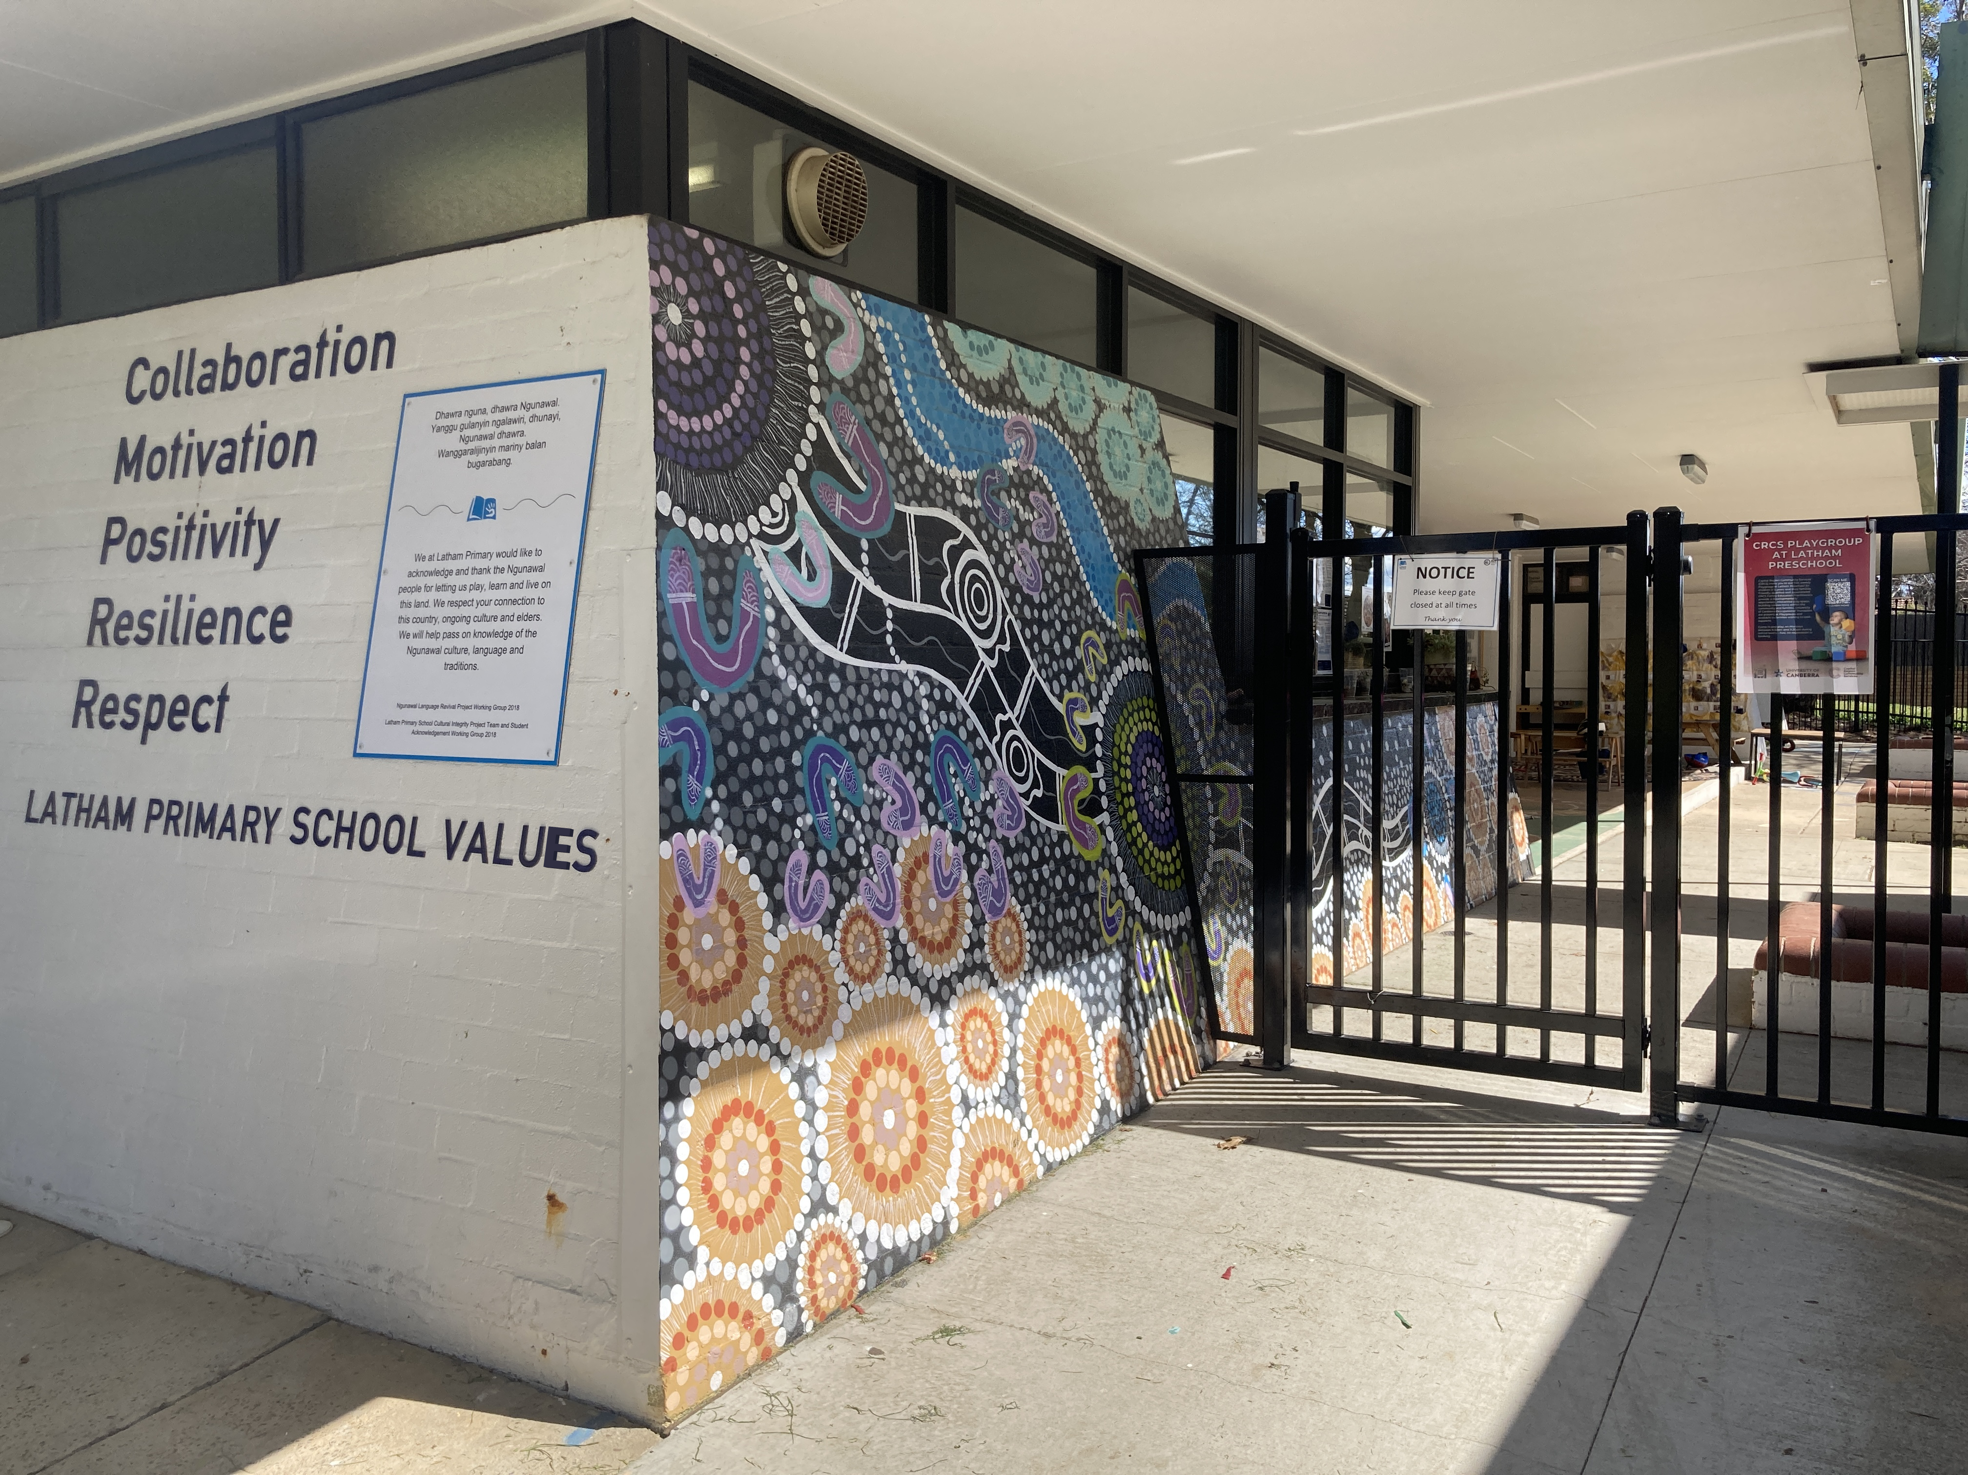

Latham School Values
Latham Learner Assets
Self-Manager
Communicator
Thinker
Collaborator
Researcher

Collaboration
Respect
Motivation
Resilience
Positivity
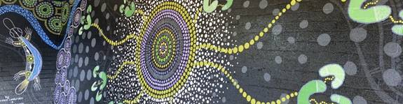

Acknowledgement of Country

Dhawra nguna, dhawra Ngunawal.
Yanggu gulanyin ngalawiri, dhunayi, Ngunawal dhwara.
Wanggaralijinyin mariny balan bugarabang.

We at Latham Primary would like to acknowledge and thank the Ngunawal people for letting us play, learn, and live on this land. We respect your connection to this country, ongoing culture, and elders. We will help pass on knowledge of Ngunawal culture, languages, and traditions.

Ngunawal Language Revival Project Working Group 2018
Latham Primary School Cultural Integrity Project Team and Student Acknowledgement Working Group 2018

A message from the Principal

Welcome to Latham Primary School! We are thrilled that you are joining our preschool unit. Starting school is an exciting time for children and families and we look forward to sharing it with you and your child.

We believe in the fundamental right to education as detailed in the United Nations Convention on the Rights of the Child (the Convention). The Convention states that “all children have the right to an education that lays a foundation for the rest of their lives, maximises their ability, and respects their family, cultural and other identities and languages. The Convention also recognises children's right to play and be active participants in all matters affecting their lives”.

Learning is the central focus for all of us here at Latham Primary School. Our school values underpin both our vision for the school, to develop global citizens and our mission, to provide a quality education where everyone belongs and embraces learning. Our school values of collaboration, resilience, motivation, respect, and positivity are recognised and celebrated across all years. Our school values were developed by our children, our staff team, and our families.

In preschool we use the Early Years Learning Framework to guide our curriculum thinking and to provide the focus for learning. The learning outcomes are not just important for children in their preschool year but flow through our whole school as well. We work to ensure that all children have a strong sense of identity, are connected with and contribute to their world, have a strong sense of wellbeing, are confident and involved learners and are effective communicators. From Kindergarten to Year 6 our curriculum planning is based on the Australian Curriculum.

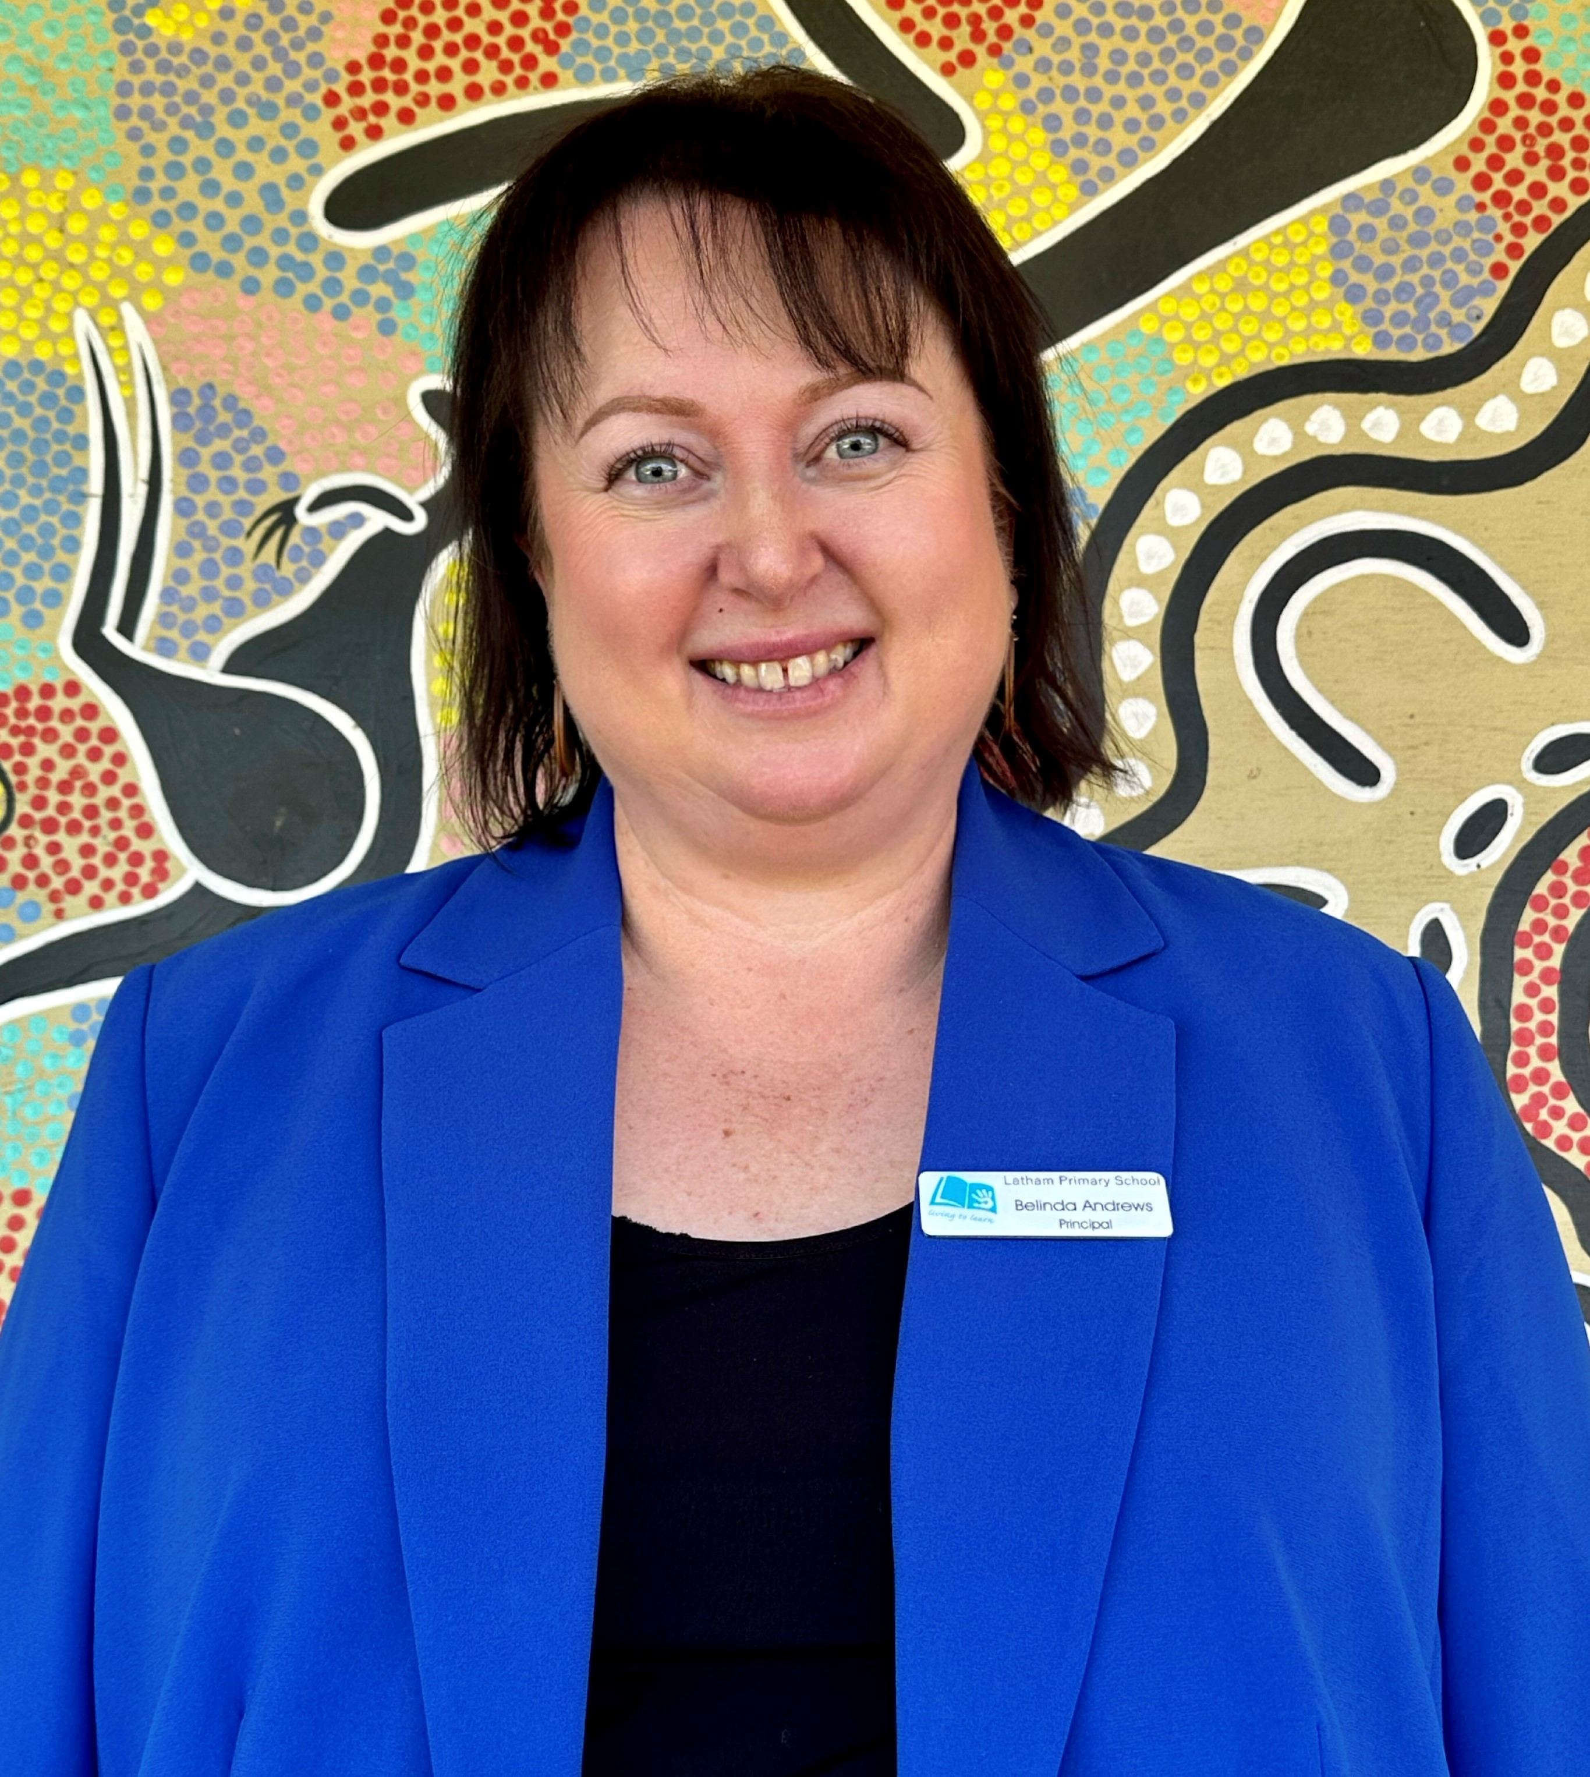
We have a strong focus and an unwavering commitment to inclusion at Latham Primary School. All children and their families are welcome here. We know that families have a deep and rich understanding of their children and to be able to tap into this knowledge helps us to be the best school possible for each child. We want to work in a true partnership with each of our families.

Latham Primary School is also committed to our Cultural Integrity journey. This involves improving our knowledge and understanding of Aboriginal and Torres Strait Islander culture and to improving outcomes for Aboriginal and Torres Strait Islander peoples.

We have a great team here at Latham who are committed to walking alongside you and your child as they start their Latham education journey. Everyone is keen and eager to help you, so if you have any questions or need help or support please ask one of our teaching or admin team.

Belinda Andrews
Principal
Latham Primary School
Nominated Supervisor of Preschool

Latham Preschool Philosophy

We believe children:
- learn through play.
- should be empowered as individuals with agency and voice.
- succeed when they feel a sense of belonging.
- are all learners.


Our practice will:
- give children opportunities to have fun every day.
- respect the rights of children and their ideas.
- support children to develop positive relationships and show kindness and respect.
- guide children to develop resilience.

As professionals we will:
- develop relationships with children, families, and other professionals.
- act in the best interests of children and their families.
- act with integrity.
- keep children safe and learning.

STARTING PRESCHOOL AT LATHAM

The start of preschool is an exciting time for the whole Latham Primary School community.

Starting school is a big step and it’s normal for children to experience all sorts of emotions as they anticipate their first day.

Families may experience a mix of nervousness and excitement. They may wonder what it will be like for their child; Will they be safe? Will they be happy? Will they make friends?

For teachers, there is also excited anticipation as they prepare for the new children they will be meeting. They plan to nurture a positive learning community and create an engaging classroom environment.

Setting individual children up for success on their educational journey is a shared responsibility. The Preschool Handbook highlights the roles of families, teachers, and students.

Starting preschool is an important step in becoming a curious and happy learner who makes a positive contribution to their community.

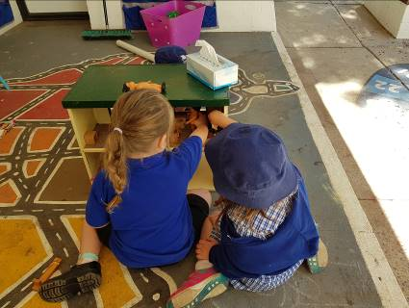
NATIONAL QUALITY FRAMEWORK

Latham Preschool is governed by the Education Directorate and is guided by all aspects of the National Quality Framework for early childhood education. This includes:

National Laws and Regulations

The National Quality Standard

Learning Frameworks – The Early Years Learning Framework

All documents are available at the preschool by request.

LEARNING FRAMEWORK
Latham Preschool uses the Early Years Learning Framework (EYLF) to ensure your child receives a quality educational program that is responsive to their ideas, interests, strengths, and abilities.
https://www.acecqa.gov.au/sites/default/files/2018-02/belonging_being_and_becoming_the_early_years_learning_framework_for_australia.pdf

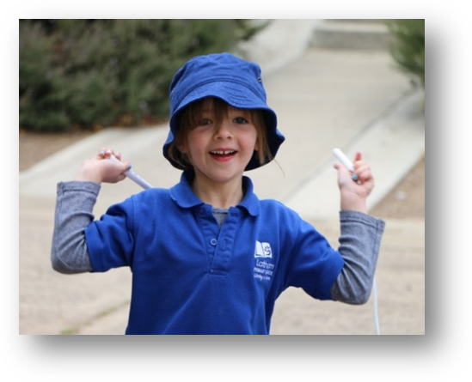
The Early Years Learning Framework describes childhood as a time of belonging, being and becoming.
- Belonging is the basis for living a fulfilling life. Children feel they belong because of the relationships they have with family, community, culture, and place.
- Being is about living in the here and now. Childhood is a special time in life and children need time to just ‘be’. This means time to play, try new things, and enjoying appreciating each moment.
- Becoming is about the learning and development. Children start to form their sense of identity from an early age, which shapes the type of adult they will become. It emphasises learning to participate fully and actively in society.
PRESCHOOL RHYTHMS:

Preschool days follow a similar routine each day, allowing for predictability and a feeling of security for children. On some days this may vary depending on the interests of children and unique opportunities for learning.

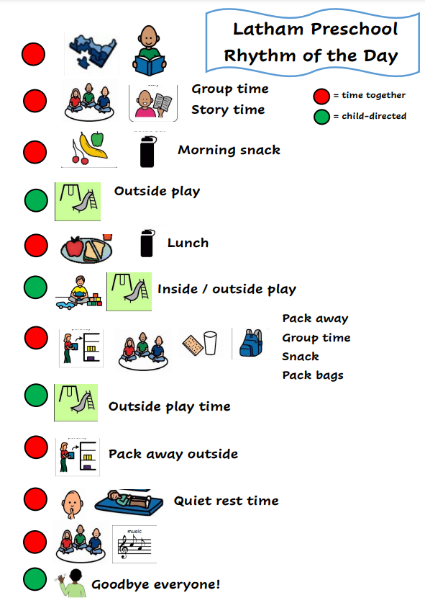

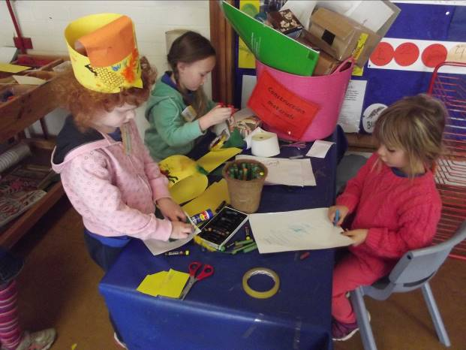
A GENERAL DAY AT PRESCHOOL
- Rhythms and routines will be established over the first few weeks. Children will build relationships, play, investigate, problem solve, and express themselves in a range of ways.
- Children will engage in intentional literacy and numeracy activities such as signing in and using rhymes and songs that play with sounds and numbers.
- Lots of time will be spent learning and developing through play.

SOCIAL WELLBEING
Children learn best when they feel a sense of belonging. Establishing friendships is a very important part of going to school. Sometimes children have challenging experiences with peers. We aim to create a safe and supportive environment where all children are respected and acknowledged. If your child is having difficulties at preschool, we encourage you to make contact with your child’s teacher.

Together we aim to:
- explicitly teach using our school values of Respect, Resilience, Positivity, Motivation and Collaboration.
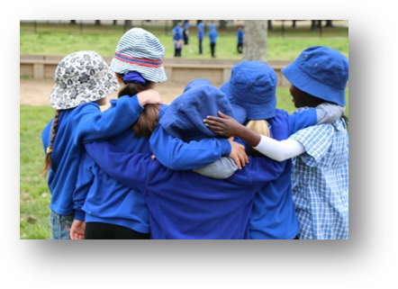
- teach your child how to navigate relationships with others by listening and communicating effectively. We encourage children to take turns, cooperate, and negotiate.
- implement the school’s positive behaviour guidelines, using ‘Shout Outs’ to recognise and promote positive behaviours.
- teach a ‘hands off, feet off’ expectation at preschool and discourage violence, whilst supporting children to negotiate conflict in other ways.
- develop a classroom culture where children feel comfortable to share their concerns and resolve conflict with support from teachers.

BEFORE AND AFTER SCHOOL
  - Preschool begins at 9:00am. If you arrive early, you are welcome to play in the playground with your child. You must supervise your child until the school day commences.
- Preschool finishes at 3:00pm. Only the child’s parents, main caregiver, or an adult authorised by them may collect your child.
- Before and after school care is offered by the YMCA for all students from preschool to year 6 at Latham Primary School. Enrolment Forms and additional information are available on the YMCA website www.canberra.ymca.org.au

PREPARING AT HOME

Look for opportunities to model to your child how exciting starting preschool is.

Help your child to succeed in the routines of a school day:

- Talk about giving the brain and body some energy for lots of learning by eating healthy food.
- Help your child to develop independence by practising toileting.
- Practise getting dressed in school uniform and taking shoes and socks off and on.
- Share some of your own stories about how you make new friends.
- Practise asking for help. Ask them to give you some ideas about what they can do if they need help. You can suggest that they ask a friend or a teacher.

For more useful information visit these parent friendly websites:

https://raisingchildren.net.au/
www.parentlink.act.gov.au

ADDITIONAL ITEMS
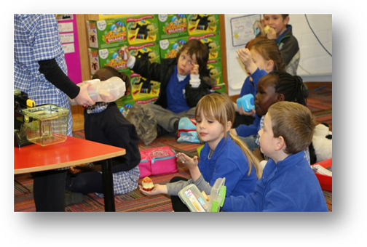
A great way to build independence is to have a backpack for school with all items inside.
You and your child can pack the following each day:
- a change of clothes including underwear and socks
- a healthy morning tea like cut up fruit, crackers and cheese, yoghurt or vegetable sticks)
- a healthy lunch like a sandwich or wrap, cold baked beans, or pasta
- Please pack separate lunch and snack boxes

Latham Primary School is a nut free school. That means all food brought to school is required to be nut free. Please support us to keep all children safe by ensuring that your child does not bring food such as Nutella, peanut butter, or muesli bars that contain nuts.

COMMUNICATION WITH FAMILIES
Latham Primary aims to provide effective communication between staff, children, and parents. Communication methods include:
- Latham Primary’s Facebook page
- the school newsletter ‘The Latham Link’ and the P&C Newsletter
- term letters that outline learning and events

- parent information evenings and workshops
- twice yearly reports
- interviews by appointment
- telephone conversations and emails
- Principal reports to the School Board and P&C
- Seesaw learning journal announcements

WORKING TOGETHER TO RESOLVE CHALLENGES

When dealing with challenging situations:
- Please speak to your child’s teacher first if you have concerns. They know your child and will be eager to help. If you would prefer to speak with someone else, please contact the school and an executive teacher will be happy to assist you.
- Should the need arise, the ACT Education Directorate has useful information about making complaints here - https://www.education.act.gov.au/support-for-our-students/complaints-feedback-and-enquiries
FIRST AID AND MEDICATION

There is always an educator with first aid qualifications at Latham Preschool. They supervise and assist with medication prescribed by a medical practitioner. Students with known medical conditions are required to have additional documentation through a Risk Minimisation and Communication Plan, administration of medication forms, in date medication, and up to date action plans. If injury or sickness requires medical attention, we notify parents as soon as possible, and we will ask you to sign an accident/injury form if required. Ambulance attendance and transport is free to students learning at ACT schools. A list of health exclusion periods is visible on the noticeboard board at preschool.

HYGIENE
Staff, children, and volunteers must adhere to hygiene procedures. All children are encouraged to wash or sanitise their hands upon arrival, before and after eating or touching food, after toileting and after blowing their nose. All scratches and cuts must be covered. Students are asked to stay home if they are unwell.

LIBRARY
Preschool classes visit the library each fortnight to borrow books. The school employs a Library Assistant who maintains and adds to the collection and organises special events.

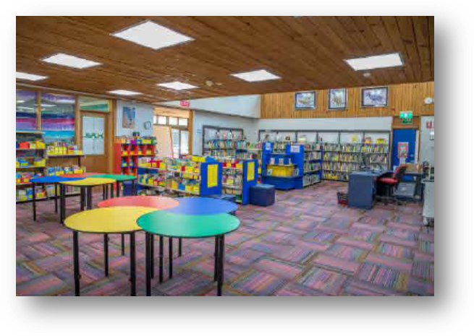

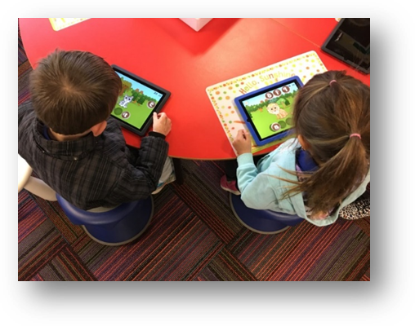
ICT DEVICES
At Latham Primary School teachers integrate technologies that support learning. Chromebooks are used across K – 6 utilising Google Apps for Education. Students from P - 6 also sometimes use iPads to enhance learning experiences. Teachers work across the school to teach about online safety and etiquette as well as the expectations outlined in the ‘Acceptable Use of ICT Code of Conduct for Students’.

SPECIALIST PROGRAMS
Latham Primary School is a P-6 school. Learning is enriched through specialist classes at the primary site and sometimes for preschool. Specialist classes include Japanese, Performing Arts, and Science.

POSITIVE BEHAVIOUR FOR LEARNING & ZONES OF REGULATION
At Latham Primary School, staff and students work together to uphold school values. Our social and emotional learning approach supports students to self-manage recognises that emotional regulation skills should be explicitly taught. We use both Positive Behaviours for Learning and The Zones of Regulation. We also have a ‘Shout Out’ system to acknowledge positive student behaviour. Students receive ‘Shout Out’ cards with an acknowledgement. Cards are taken home to celebrate with families and each Shout Out also earns house points.
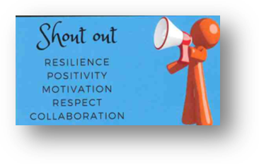

HOUSE TEAMS
There are three houses named after local places.
Umbagong (green) – named after Umbagong Park
Brindabella (blue) – named after the Brindabella Ranges
Casuarina (yellow) – named after Casuarina Sands

Students are placed into house teams on enrolment. Siblings will be in the same house. Students also represent their houses at sporting carnivals.

POLICIES AND PROCEDURES

Please see a staff member if you are interested in our policies and procedures. For updates on Education Directorate policies please check the website: www.education.act.gov.au
EMERGENCY MANAGEMENT
We practise emergency evacuations and lockdowns each term. Preschool educators will inform you when they have taken place. Should your child require support in this area please notify the preschool team.
CHILD PROTECTION
All employees in schools have completed training in this area and are mandated to report any case of suspected child abuse or neglect. Preschool teachers talk to students about personal safety in a way that meets the developmental understandings of young children.

COLLECTION OF MONEY

Preschool may conduct excursion or incursion visits during the year. Information will come home with a permission note and payment information. Online payments through QUICKWEB Direct Deposit are the preferred method payment. If sending cash to school, please send payments to the class teacher in an envelope bearing the child’s name, amount enclosed, and purpose. The school is ready to support families who may need assistance with payments.

CANTEEN - THE LATHAM LUNCHBOX


The Latham Lunchbox school canteen is run by the Parents and Citizens Association (P&C). It provides a wide range of foods and snacks for students and teachers 3-4 days a week, Tuesday – Thursday with occasional specials on Fridays. Preschool lunch and recess orders are welcome. There are no counter sales for preschoolers. For the latest menu and meal deals or to place an order check out https://www.flexischools.com.au/.

UNIFORM

Students attending Latham Preschool are asked to wear school uniform. The uniform comprises of black pants, skirt or shorts and royal blue polo shirts, jumpers, and a broad-brimmed hat, legionnaire, or bucket hat. It is also important to wear sensible shoes.

The Latham Primary School community believes a school uniform:
- fosters and enhances the public image of the school
- assists in building school and team spirit
- ensures students are safely dressed for specific school activities
- encourages equity among students.

Uniforms can be purchased through the P&C uniform shop at https://www.lathampandc.org.au/
Ensure you enter your child’s name and class when placing an order.

Second hand uniforms are also available at a reduced rate. To order, please contact the uniform shop via uniforms.lathampandc@gmail.com to ensure stock is available.

PARENTAL INVOLVEMENT AND VOLUNTEERING
Family and community volunteers are a vital component of our school community and are often invited to help in the classroom. Volunteers are required to gain a Working with Vulnerable People card and present this to the preschool staff. Volunteers must sign in and out of the preschool site. Regular volunteers will be required to complete a visitor record with additional information for compliance purposes.

Volunteering for the P&C is rewarding, and children love seeing their family members helping. Regardless of how much time you have there are many ways you can assist. We welcome involvement from families and no school experience is required. Visit https://www.lathampandc.org.au/volunteer/ for more ways you can volunteer.

PARENTS AND CITIZEN ASSOCIATION (P&C)
The Latham Primary School P&C is focused on supporting children, families, the school, and the community through:
- providing low-cost uniforms through the Uniform Shop
- offering cost effective healthy food choices provided through the Latham Lunchbox Canteen
- hosting free nutritious breakfasts for students at the Breakfast Club
- giving children the opportunity to thank their parents and significant others with gifts on Mothers’ and Fathers’ Days
- aiding families in need by helping with uniforms and school lunches
- organising events for children and families like discos, movie nights and fetes
- fundraising to enhance students’ learning experiences
- sponsoring the Community Hub and school P&C website

To find out more, read the P&C update in each school newsletter, visit www.lathampandc.org.au or join the Facebook group by searching for ‘Latham Primary School P&C’.

SCHOOL BOARD
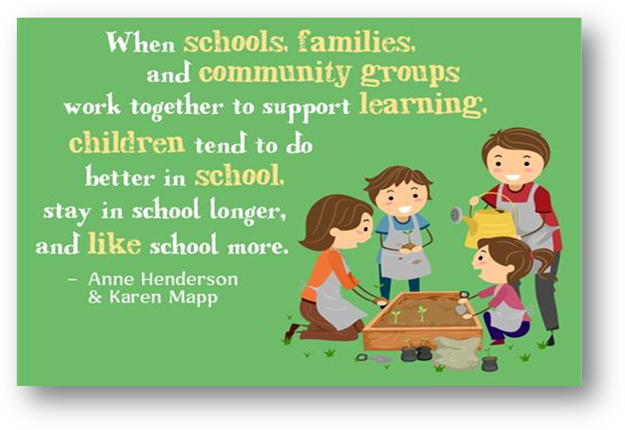
The Education Act 2004 requires that a School Board be established for each public school. It describes the functions of School Boards, including their role in Principal selection, the constitution of School Boards, the proceedings of Board Meetings, and the responsibilities associated with financial and reporting requirements.

The Board is responsible for the school’s strategic direction. Operational matters are the responsibility of the Principal. Parents are invited to apply for advertised vacancies on the School Board as they arise. Vacancies are advertised in the school newsletter.

CONTACT DETAILS
Latham Primary School 48 O’Loghlen Street
Phone – 6142 0077 LATHAM, ACT 2615
Email – info@lathamps.ed.act.edu.au
Website - www.lathamps.act.edu.au
Before and after school care (YMCA) – www.canberra.ymca.org.au.
Preschool – 6142 0088 and 6142 0094
School Canteen – 6142 0095 or lathamlunchbox@gmail.com if you have a general enquiry.

Principal: Belinda Andrews
belinda.andrews@ed.act.edu.au

Deputy Principal: Natalie Garrett
natalie.garrett@ed.act.edu.au

Executive P - K: Samuel Bird
samuel.bird@ed.act.edu.au

Latham School Board
lathamprimaryschoolboard@gmail.com

Latham P&C
lathamprimarypandc@gmail.com



